**Name : Salman Bashir**

**Roll no.: P17-6034**

**Section : CS-A**

**Documentation**

(**This file contain documentation of errors faced during the courses of python from code school and their solution**)

**URL:** [**https://www.codeschool.com/courses/try-python**](https://www.codeschool.com/courses/try-python)

**ERROR FACED IN PYTHON LANGUAGE**

**Brackets:**

**During the tasks of python code school. I was adding the brackets at the wrong place**

**Solution:**

**I read the question carefully and added the brackets according to the question**

**Syntax:**

**Different in different programming language:**

**This is the common mistake that occurs if a programmer Is not aware of the syntax of programming language. In the python we use colon and in c++ we use semicolon after every statement. I put semicolon after defining function in python.**

**Typing Error:**

**Solution:**

**Code was not giving correct answer so I debug using print”a” command after every single line. I was writing else statement outside the function**.

**Indentation:**

**Indentation error faced during my course**

**Solution:**

**I faced indentation error many times I rectified that errors by looking at the body of codes. Python is a language that forces you to indent. On the other hand other language other programming languages don’t forces you to indent but it is a good practice in order to make the code more readable.**

**Recursion:**

**Solution:**

**This happens due to lack of concepts. i just know that recursion is a process in which a function call itself. But cant use recursion as loop. So, I recalled my lecture taken in the class which clears my concept of recursion**

**Logical Error:**

**Solution:**

**use return instead of print command in function if u want to return output of function and function call must be after loading the function in the memory.**

**Attribute Error:**

**Solution:**

**Error in module of a library. for example form math import py it will give Attribute Error.**

**Errors in statement:**

**Trapped in the statements**

**Solution:**

**During my online course of python school code .When complex code came I was trapped in the statement. So I read the question of the code carefully and resolved my problem**

**Error Faced in C++**

**Code Braces{ }:**

**I faced many error in the loops I wasn’t able to recognize the braces{} of loop which is main thing in c++ while applying loops**

**Solution:**

**I rectify this mistake of mine by following Sir Shakir Ullah shah’s instruction. Which lead me like a bright way to the solution of problem. And I did a lot of practice in the class task.**

**Logical Error:**

**I was not using correct logic for input and output. I was typing (cin<<) instead of (cin>>)**

**Syntax Errors**

**these are detected at compile time and you won't be able to run your program until these are fixed. Listed are the errors that you will see if you are using the Visual Studio C++ compiler. Syntax errors will be displayed on the Output window. Here is a screen-shot with an error shown circled in red:**

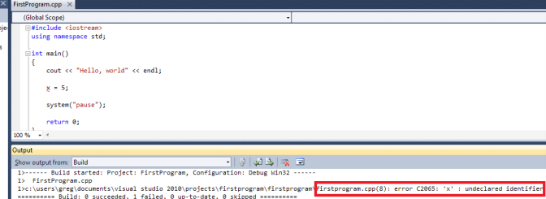

**Missing semi colons:**

**Sometimes I forgot to put semicolons after each line, so I worked a lot on this problem**

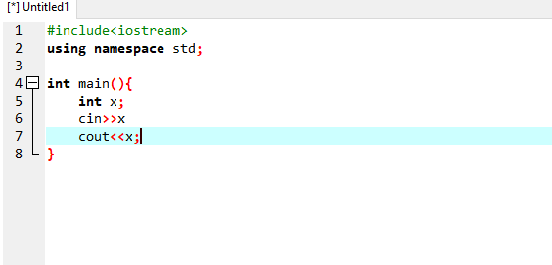

**Forgetting the Break in switch statement:**

**When I learned switch statement I forget to type the break at the end of each case**

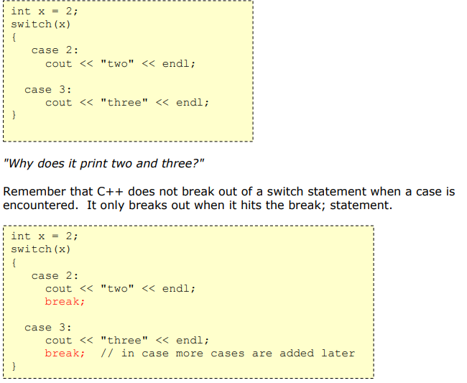

**NOT FOLLOWING A CONSISTENT WRITING STYLE**

* **Don’t have consistent indentation**
* **Don’t use a clear convention for naming things**
* **Don’t provide meaningful names for things**
* **Don’t have meaningful but concise comments**

## USING A STREAM OBJECT WITHOUT CHECKING FOR FAIL

int value;

while(!input.eof())

{

input >> value;

processValue(value)

}

**The following loop is far preferable:**

int value;

while(!input.eof())

{

input >> value;

if (input.fail())

{

break;

}

processValue(value)

}